**Problem formulation :**

* **Problem:**
* The absence of a user-friendly e-commerce platform for cookie sales hampers business growth. Current solutions lack efficiency, risking suboptimal user experiences, inadequate product management, and potential security issues.
* **Solution:**
* Develop a robust e-commerce platform for cookie sales, prioritizing user and administrator satisfaction. The platform will excel in product management, user security, and communication, setting a new standard in the online cookie market.
* **Objectives:**
* **User Experience Excellence:**
  + Intuitive design for easy navigation.
  + Responsive interface for various devices.
* **Efficient Product Management:**
  + Simple product management for easy updates.
  + Categorization for product organization.
* **Communication Facilitation:**
  + User-friendly feedback system.
  + customer support.
* **Scalability:**
  + Handle growth in products and users.

**Requirements :**

* **Functional requirements :**
* **Admin :**
* **Product Management:**

1- Add new cookies to the inventory with details.

2- Edit/update existing product information.

3- Remove products.

* **User Management:**

1- View and manage user accounts.

2- Remove accounts if necessary.

3- Reset user passwords.

* **Order Management:**

1- View and process incoming orders.

* **Feedback Management:**

1- Access and review customer feedback messages.

* **User :**
* **User Registration and Authentication:**

1-Allow users to create/delete accounts and log in/log out.

2-Update personal profile information (name, shipping address…).

* **Shopping Cart and Check-out:**

1-Add cookies to a shopping cart and adjust quantities.

2-Calculate order totals, including shipping costs.

3-Proceed through a checkout process with multiple payment options.

4-Apply discounts and promotions at checkout.

5-Select the preferred shipping method and delivery address.

* **Wishlist:**

1-Users can create and manage Wishlist.

2-User can transfer items from Wishlist to cart.

2-Users can stop notifications whenever they want.

* **Order History:**

1-View order history and track the status of current orders(shipping updates, and delivery information).

* **Product Reviews and Ratings:**

1-Leave reviews and ratings for purchased cookie products.

2-send messages for inquiries, issues, or feedback.

* **Non-Functional Requirements:**
* **Performance:**

1-The website should be able to handle a high volume of traffic.

2-The website should be able to process transactions quickly.

3-The website should be able to load pages quickly.

* **Security:**

1-The website should be secure from hackers.

2-The website should protect customer data.

3-The website should use secure payment processing methods.

4-The website should protect user reviews from unauthorized access.

**- Usability:**

1-The website should be easy to use.

2-The website should provide a clear and concise product description.

3-The website should provide a way to easily leave reviews.

* **Reliability:**

1-The website should be reliable and available 24/7.

2-The website should be able to recover from failures quickly.

3-The website should be able to handle a large volume of user reviews.

4-The website should be able to recover from data loss quickly.

* **Scalability:**

1-The website should be able to accommodate a growing product catalog.

2-The website should be able to handle increasing user review volumes.

3-The website should be able to handle increasing traffic volumes.

* **Activity diagrams :**
* **Customer :**

**- Admin :**

**-Use case diagram:**

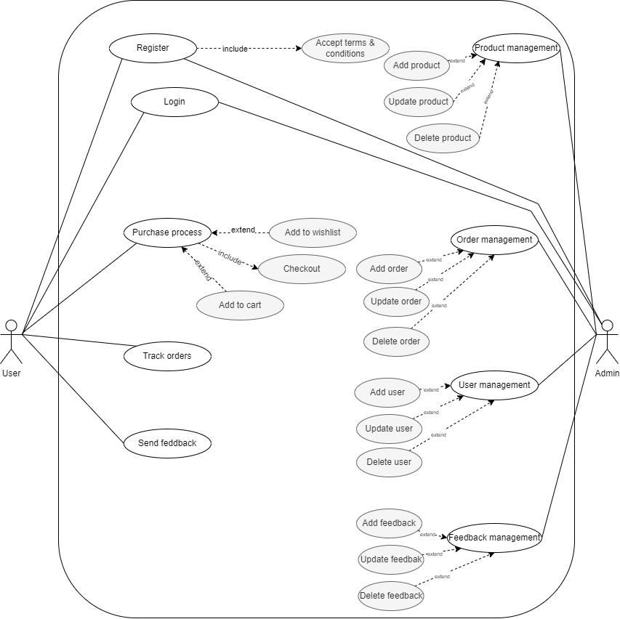

**-Use case descriptions:**

**1-Admin login**

|  |  |
| --- | --- |
| **Use case ID** | **UC-01** |
| **Use case name** | **Admin Log In** |
| **Preconditions:** | **-Admin credentials (username and password) are valid and registered in the system.** |
| **Postconditions:** | **-Admin is successfully authenticated and gains access to the admin dashboard.**  **- In case of unsuccessful login attempts, the system provides appropriate error messages.** |
| **Actor:** | **Admin** |
| **Trigger:** | **-Admin navigates to the login page and enters valid credentials.** |
| **Goal:** | **-To authenticate the admin and grant access to the admin dashboard.** |
| **Standard Process (Main Success Scenario):** | **- Admin navigates to the login page.**  **- The system presents a login form requesting the admin's username and password.**  **-Admin enters valid credentials.**  **-System verifies the credentials against the stored data.**  **If the credentials are valid:**  **a. System grants access to the admin dashboard.**  **b. Admin gains the ability to perform admin-level functions (product management, user management, order management, feedback management).**  **c. System logs the successful login for security purposes.**  **If the credentials are invalid:**  **a. System displays an error message indicating the login failure.**  **b. Admin is prompted to re-enter the credentials.** |

**2- Product Management**

|  |  |
| --- | --- |
| **Use case ID** | **UC-02** |
| **Use case name** | **Admin Product Management** |
| **Preconditions:** | **-Admin is logged into the system.**  **-The admin has the necessary permissions for product management.** |
| **Postconditions:** | **-Product information is successfully updated in the system, changes are reflected in the user interface.** |
| **Actor:** | **Admin** |
| **Trigger:** | **-Admin selects the "Product Management" option from the admin dashboard.** |
| **Goal:** | **-To manage and update product information in the system.** |
| **Standard Process (Main Success Scenario):** | **-Admin logs into the system using valid credentials.**  **-Admin navigates to the admin dashboard.**  **-Admin selects the "Product Management" option.**  **-System displays a list of existing products.**  **-Admin selects a specific product to manage.**  **-System presents options for product management, including:**  **a. View product details.**  **b. Edit product information (name, price, description, etc.).**  **c. Add new products to the inventory.**  **d. Delete existing products.**  **- Admin chooses an action and provides the necessary details.**  **-System updates the product information.**  **- Changes are reflected in the product list.** |

**3- User management**

|  |  |
| --- | --- |
| **Use case ID** | **UC-03** |
| **Use case name** | **Admin Users Management** |
| **Preconditions:** | **-Admin is logged into the system.**  **-The admin has the necessary permissions for user management** |
| **Postconditions:** | **-User information is successfully updated in the system, and Changes are reflected in the user interface.** |
| **Actor:** | **Admin** |
| **Trigger:** | **-Admin selects the "User Management" option from the admin dashboard.** |
| **Goal:** | **-To manage and update user information in the system.** |
| **Standard Process (Main Success Scenario):** | **-Admin logs into the system using valid credentials.**  **-Admin navigates to the admin dashboard.**  **-Admin selects the "User Management" option.**  **-System displays a list of existing users.**  **-Admin selects a specific user to manage.**  **-System presents options for user management, including:**  **a. View user details.**  **b. Edit user information (name, email, etc.).**  **c. Add new users to the system.**  **d. Deactivate or delete existing user accounts.**  **Admin chooses an action and provides the necessary details.**  **The system updates the user information.**  **Changes are reflected in the user list.** |

**4- Orders management**

|  |  |
| --- | --- |
| **Use case ID** | **UC-04** |
| **Use case name** | **Admin Orders Management** |
| **Preconditions:** | **-Admin is logged into the system.**  **-The admin has the necessary permissions for order management** |
| **Postconditions:** | **-Order information is successfully updated in the system.**  **-Changes are reflected in the order status and relevant user accounts.** |
| **Actor:** | **Admin** |
| **Trigger:** | **-Admin selects the "Order Management" option from the admin dashboard.** |
| **Goal:** | **-To manage and update order information in the system.** |
| **Standard Process (Main Success Scenario):** | **-Admin logs into the system using valid credentials.**  **-Admin navigates to the admin dashboard.**  **-Admin selects the "Order Management" option.**  **-System displays a list of existing orders, including order details (order number, total, etc.).**  **-Admin selects a specific order to manage.**  **- System presents options for order management, including:**  **a. View detailed order information.**  **b. Update order status (e.g., processing, shipped, delivered, canceled).**  **c. Add or remove products from the order.**  **Admin chooses an action and provides the necessary details.**  **The system updates the order information.**  **Changes are reflected in the order list and relevant user accounts.** |

**5-Feedback management**

|  |  |
| --- | --- |
| **Use case ID** | **UC-05** |
| **Use case name** | **Admin Feedback Management** |
| **Preconditions:** | **-Admin is logged into the system.**  **-The admin has the necessary permissions for feedback management.** |
| **Postconditions:** | **-Feedback information is successfully processed and may influence improvements in the system.** |
| **Actor:** | **Admin** |
| **Trigger:** | **-Admin selects the "Feedback Management" option from the admin dashboard.** |
| **Goal:** | **-To manage feedback provided on the website.** |
| **Standard Process (Main Success Scenario):** | **-Admin logs into the system using valid credentials.**  **-Admin navigates to the admin dashboard.**  **-Admin selects the "Feedback Management" option.**  **-System displays a list of user feedback, including details such as the user's name, date, and feedback content.**  **-Admin selects a specific feedback entry to manage.**  **-System presents options for feedback management, including:**  **a. View detailed feedback content.**  **b. Categorize the feedback (e.g., positive, negative, suggestion).**  **Admin chooses an action and provides the necessary details.**  **If necessary, the admin communicates with the user for clarification or additional information.**  **Changes are reflected in the feedback list.** |

**6-User registration**

|  |  |
| --- | --- |
| **Use case ID** | **UC-06** |
| **Use case name** | **User Registration** |
| **Preconditions:** | **-The user is accessing the website for the first time.**  **-The user has a valid email address.** |
| **Postconditions:** | **-User account is successfully created.**  **-User is logged into the system.** |
| **Actor:** | **User** |
| **Trigger:** | **-User clicks on the "Sign Up” button.** |
| **Goal:** | **-To create a new user account on the website.** |
| **Standard Process (Main Success Scenario):** | **-User navigates to the registration page.**  **-System presents a registration form, requesting information such as name, email, password, etc.**  **-User enters valid registration details.**  **-System validates the entered information.**  **- If validation is successful:**  **a. System creates a new user account.**  **The user account is activated, and the user is redirected to the login page.**  **The user logs in with the newly created credentials.** |

**7-User login**

|  |  |
| --- | --- |
| **Use case ID** | **UC-07** |
| **Use case name** | **User Login** |
| **Preconditions:** | **The user account is successfully registered.**  **The user has valid login credentials.** |
| **Postconditions:** | **The user is successfully authenticated and logged into the system.**  **-User gains access to personalized features.** |
| **Actor:** | **User** |
| **Trigger:** | **-User clicks on the "Log In" button.** |
| **Goal:** | **-To access the user account on the website.** |
| **Standard Process (Main Success Scenario):** | **-User navigates to the login page.**  **-System presents a login form, requesting the user's email and password.**  **-User enters valid login credentials.**  **-System verifies the credentials against the stored data.**  **If the credentials are valid:**  **a. System logs the user into the system.**  **b. User gains access to personalized features (cart, wish list, etc.).**  **c. User is redirected to the main user page (cookies page).**  **If the credentials are invalid:**  **a. System displays an error message indicating the login failure.**  **b. The user is prompted to re-enter the credentials.** |

**8-User feedback**

|  |  |
| --- | --- |
| **Use case ID** | **UC-08** |
| **Use case name** | **User Feedback** |
| **Preconditions:** | **The user is logged into the website.**  **-The user is on the "Contact Us" page.** |
| **Postconditions:** | **-Feedback is successfully submitted through the contact form.**  **-The feedback is shown in the admin dashboard in the feedback management part.** |
| **Actor:** | **User** |
| **Trigger:** | **-User clicks on the "Contact Us" link or button.** |
| **Goal:** | **-To provide feedback or inquiries through the website's contact form.** |
| **Standard Process (Main Success Scenario):** | **-User navigates to the "Contact Us" page.**  **-System presents a contact form with fields such as name, email, and message.**  **-User fills in the required information and provides feedback in the message field.**  **-User clicks on the "Submit" or "Send" button.**  **-System validates the entered information.**  **If validation is successful:**  **a. System records the feedback in the admin dashboard.** |

**10-User add product to the cart**

|  |  |
| --- | --- |
| **Use case ID** | **UC-10** |
| **Use case name** | **User Add Product to Cart** |
| **Preconditions:** | **-User is logged into the website.**  **-User is on the product details page or a page displaying the product.** |
| **Postconditions:** | **-Product is successfully added to the user's cart.**  **-User has the option to proceed to checkout.** |
| **Actor:** | **User** |
| **Trigger:** | **-User clicks the "Add to Cart" button on the products page.** |
| **Goal:** | **-To add a specific product to the user's shopping cart.** |
| **Standard Process (Main Success Scenario):** | **-User navigates to the product details page or a page displaying the product.**  **-User clicks the "Add to Cart" button.**  **-System adds the selected product to the user's shopping cart.**  **-System updates the cart icon to reflect the added product.**  **-Optionally, User can continue shopping or proceed to the cart for checkout.** |

**11-User add product to the Wishlist**

|  |  |
| --- | --- |
| **Use case ID** | **UC-11** |
| **Use case name** | **User Add Product to Wishlist** |
| **Preconditions:** | **-User is logged into the website.**  **-User is on the product details page or a page displaying the product.** |
| **Postconditions:** | **-Product is successfully added to the user's Wishlist.**  **-User can view and manage products in their Wishlist.** |
| **Actor:** | **User** |
| **Trigger:** | **-User clicks the "Add to Wishlist" button on the products page.** |
| **Goal:** | **-To add a specific product to the user's Wishlist for future reference.** |
| **Standard Process (Main Success Scenario):** | **-User navigates to the product details page or a page displaying the product.**  **-User clicks the "Add to Wishlist" button.**  **-System adds the selected product to the user's Wishlist.**  **-Optionally, user can continue shopping or view their Wishlist for later reference.** |

**12-User track the order**

|  |  |
| --- | --- |
| **Use case ID** | **UC-12** |
| **Use case name** | **User Track the Order** |
| **Preconditions:** | **-User is logged into the website.**  **-User has placed an order recently.** |
| **Postconditions:** | **-The user is provided with information on the order status.**  **-User may receive notifications for significant order updates.** |
| **Actor:** | **User** |
| **Trigger:** | **-User clicks on the "orders" option in the user account or order confirmation page.** |
| **Goal:** | **-To check the status and details of a placed order.** |
| **Standard Process (Main Success Scenario):** | **-User logs into their account on the website.**  **-User navigates to the "Order History" or "Track Order" or "My Orders" section.**  **-System displays a list of the user's recent orders.**  **-User selects the specific order they want to track.**  **System presents order information, including status, estimated delivery date.** |

* **Data flow diagrams:**
* **Context Diagram:**

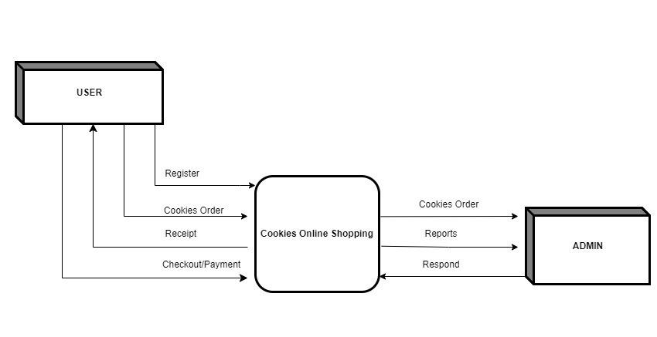

**-Class Diagram**

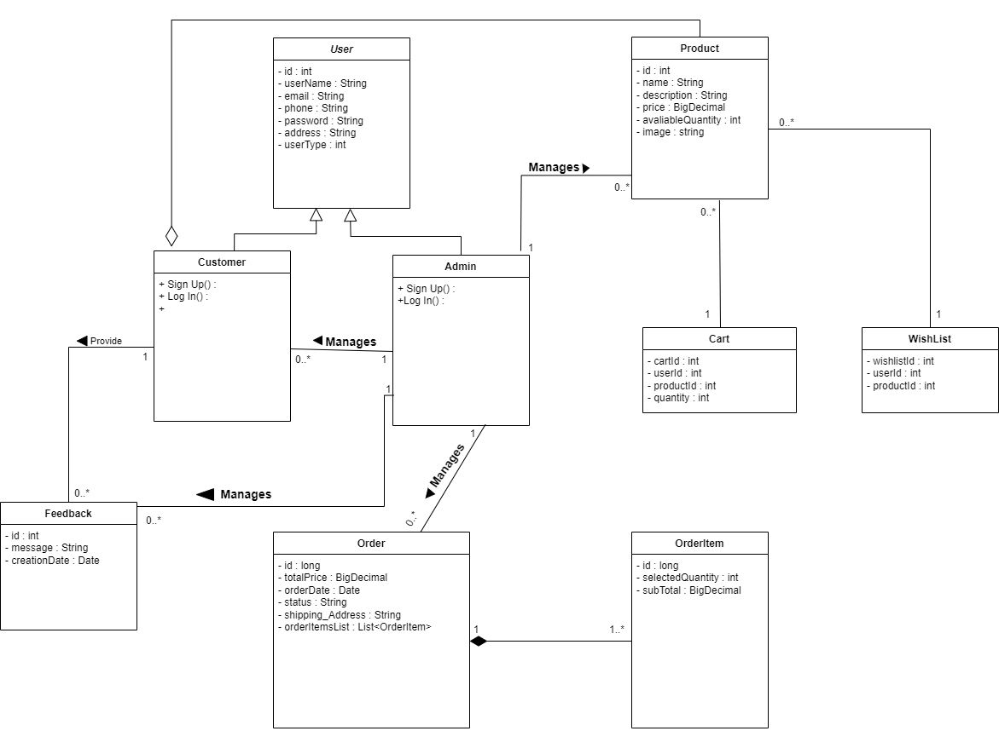

**-Sequence diagrams:**

**-User : login**

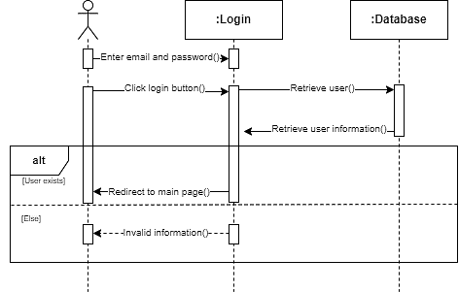

**-Customer : registration**

**-Customer : Place an order**

**-customer : Send feedback**

**-Admin : Dashboard management**

